Sample Size and Portfolio Construction

**Contents**

1 Case Study Data 2

2 Monthly returns 3

3 Mean and standard deviation of monthly returns for the DJIA index calculation 3

4 Equally weighted portfolios constructing 4

5 Portfolios monthly returns calculation 4

6 Mean and standard deviation for portfolios 4

7 Tracking errors calculation 5

8 Results representation 6

9 Conclusion 7

# Case Study Data

Dow Jones Industrial Average (DJIA) and each of the 30 component stocks have data for last 3 years were downloaded from Yahoo! To calculate returns the data were converted into time series.

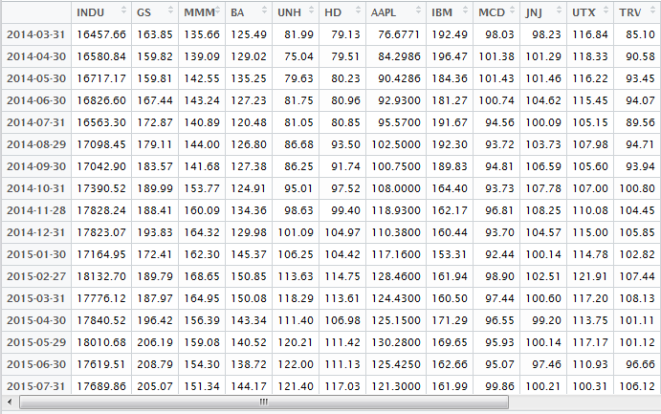

Figure 1 - Time series for index and 30 stocks

# Monthly returns

The second step was to calculate monthly returns for the index and all underlying stocks. For this purpose **Return.calculate( )** function from library “**PerformanceAnalytics**” was used.

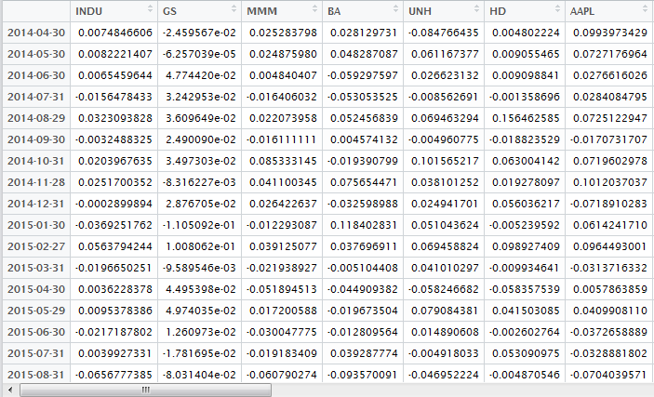

Figure 2 - Monthly returns

# Mean and standard deviation of monthly returns for the DJIA index calculation

Index performance is a benchmark for our research, so, firstly index mean and standard deviation were calculated. Standard **mean( )** and **sd( )** functions were used.



Figure 3 - index mean and standard deviation

# Equally weighted portfolios constructing

The idea of the research is to compare performance of the index with the performance of the different portfolios, which contains less than 30 stocks. According to this idea, five different portfolios were constructed (5, 10, 15, 20, 25 randomly selected stocks from the index).

**Sample( )** function was used to randomly choose necessary stocks for mentioned portfolios. As a result, five time series (for five portfolios) with monthly returns were created.

# Portfolios monthly returns calculation

After five portfolios were ready, their monthly returns were calculated. For this purpose I created my own function that calculates returns for equally weighted portfolio (function name is **GetPortfolioReturns**)



Figure 4 – 5 stocks portfolio returns calculation

As a result, I had five vectors for five portfolios with monthly returns.

# Mean and standard deviation for portfolios

The next step was to mean and standard deviation calculation for all five portfolios. The same approach as with index was used here. As a result, I had five mean and five standard deviations (for each portfolio).

# Tracking errors calculation

Having benchmark mean and standard deviation and portfolios ones, the margin by which the mean and standard deviation of the portfolio returns diverge from those of DJIA could be found.



Figure 5 - Mean margin calculation



Figure 6 - Standard deviation margin calculation

The same formula was used for all portfolios. As a result, I had five mean margins and five standard deviation margins:

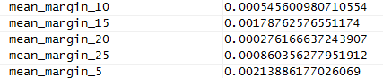

Figure 7 - mean margins

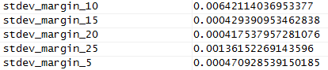

Figure 8 - standard deviation margins

# Results representation

The first result was very far from the theoretical expectation. Based on central limit theorem I expected margin to become smaller, when number of stocks in a portfolio increased. However in was not every time so.

Then I decided to repeat all the procedure for 100 times in the loop and check average margin for 5-stocks, 10-stocks, 15-stocks, 20-stocks, 25-stocks portfolios.

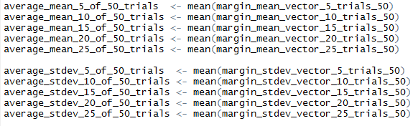

Figure 9 - 100 trials experiment

After that, the whole picture became clear and understandable:

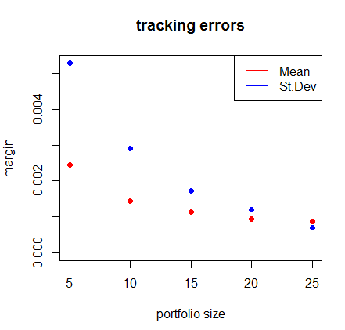

Figure 10 - mean and standard deviation are gradually decreasing

# Conclusion

It is clear that portfolio performance depends on underlying stocks performance. Therefore, the first factor is underlying stocks. Based on this fact, we can conclude that it is possible to have 5-stocks portfolio that performs very similar with the index. However, in general, the more stocks from the index portfolio contains the more similar it behaves. Therefore, the second factor is the number of stocks in a portfolio. The third factor is the approach of a portfolio creation (e.g. equally weighted or not).

To decrease tracking error without having to construct a full portfolio matching the entire index, we need to:

1. Investigate the way of index construction
2. Take firstly stocks that have higher influence
3. Use correlation and beta to choose stocks
4. Take as many stocks as possible